Avanti Learning Centres

2014 - 2016

# P7. Gravitation

### TABLE OF CONTENTS

P7. Gravitation 1

P7.1 Kepler’s Law and Newton’s Law of Gravitation…………………………….…………………………………………………. 2

P7.2 Gravitational Field…………….………………………………………………………………………...………………………………… 8

P7.3 Gravitational and Potential energy…………….……………………………………………….………………………………… 12

P7.4 Earth’s Gravity…………….…………………………………………………………………………….………………………………… 15

P7.5 Satellite and Orbits…………….…………………………………………………..………………….………………………………… 18

Miscellaneous Objectives…………….……………………………………….…………………………….………………………………… 22

## P7.1 Kepler’s Law and Newton’s Law of Gravitation

Learning objectives

1. Write the Newton’s Laws of gravitation for any two point masses or system of point masses.
2. Determine the gravitational force acting between two point masses.
3. Understand the universal gravitation constant, G.
4. Calculate the gravitational force due to any number of particles on a particular particle.
5. Explain the three laws of Kepler and derive them from the Newton’s laws of gravitation.
6. Derive the second and third law of Kepler mathematically.

#### Pre-Reading

|  |  |  |  |
| --- | --- | --- | --- |
| Category | Book Name (Edition) | Chapter | Section |
| REQUIRED | NCERT XI | 8 | 8.1 to 8.4 |
| ADDITIONAL | Concept of Physics, H. C. Verma | 11 | 11.1, 11.2 |

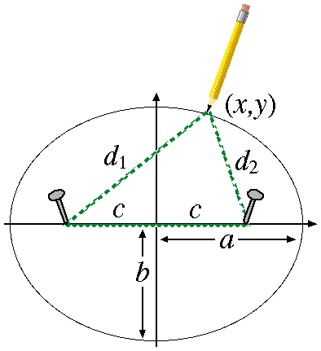**Theories of planetary motion**

Since the earliest of times, people were observing the heavenly bodies like sun, stars, planets etc. and their movement. The same was the subject of attention of many scientists. The first authoritative work regarding the planetary motion was done by **Ptolemy**, a Greek astronomer, about 200 years ago. His theory was called **geocentric theory of planetary motion.**

According to this theory, all the heavenly bodies like sun, stars, planets, moon etc. are moving around the earth and was taken as the centre of the universe. As geocentric means a system with earth as the centre, hence the name geocentric theory. This theory was challenged by **Copernicus**.

In 948 A.D, (i.e. around 500 years earlier than Copernicus) a great Indian mathematician and astronomer, **Arya Bhatta**, from his observation concluded that the various facts (like solar eclipse, moon eclipse, formation of day and night etc.) can be very easily explained by considering that the earth revolves around the sun and also rotates on its axis. However his idea could not be communicated to the western philosophers.

In 1543, Copernicus suggested that description of motion of heavenly bodies would be simplified and more properly explained if we assume that sun is stationary and earth as well as other planets are revolving around it. This theory is called heliocentric theory. This theory was later on supported by Galileo from his experimental study on moon and other planets.

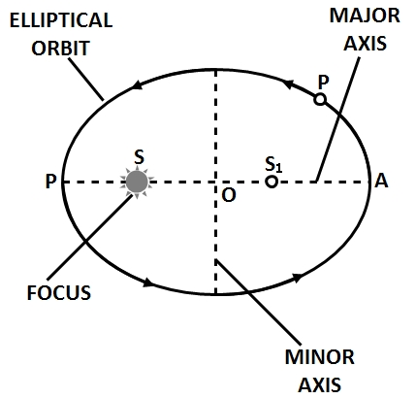**Kepler’s law of planetary motion**

Kepler carried out the analysis of the whole astronomical data on the basis of Copernicus theory. As a result of his investigations, he formulated the following three laws of planetary motion.

1. **Kepler’s first law (Law of orbits): Every planet revolves around the sun in an elliptical orbit. The sun is situated at one of the foci of the ellipse (see figure).**

The eccentricity of the orbit is slight and the orbits may be taken as nearly circular.

Kepler’s first law (law of orbits) is based on “Inverse Square law”. In given figure, the closest point is $P$, called **perihelion** and the farthest point is $A$, called **aphelion**. The mid-point $O$ of the line $PA$ is the centre of the ellipse. The length $PO=AO$, is called the semi-major axis of the ellipse.

For a circle, the two foci of the ellipse merge into one and the semi-major axis becomes the radius of the circle.

1. **Kepler’s Second law (law of Areas): The line joining a planet to the sun sweeps out equal areas in equal intervals of time, $i.e.,$ the areal velocity of the planet around the sun is constant.**

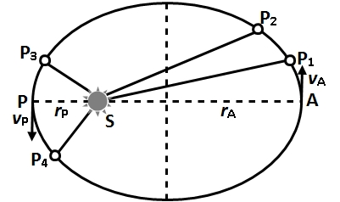 To keep the areal velocity constant, the linear speed of the planet goes on changing. The linear speed is more, when the planet is close to the sun and less, when it is away from the sun. To understand it, a planet moves form $P_{1}$ to $P_{2}$ or from $P_{3}$ to $P_{4}$ in the same time $t$ (figure 2). In this situation.

Area $P_{1} S P_{2}≡$ Area $P_{3} S P_{4}$

Since, $SP_{1}>SP_{3}$, therefore, $P_{1}P_{2}<P_{3}P_{4}$

Or, $\frac{P_{1}P_{2}}{t}<\frac{P_{3}P_{4}}{t}$ (1)

Hence, $\frac{P_{1}P_{2}}{t}=$ linear speed of the plane at position $P_{1}$,

$\frac{P_{3}P_{4}}{t}=$ linear speed of the planet in position $P_{3}.$

Thus, from (1), we note that the linear speed of the planet when close to the sun is more than its linear speed when away from the sun.

Kepler’s second law (law of areas) is based on law of conservation of angular momentum. According to this,

$mv_{P}r_{P}={mv}_{A}r_{A}$ or $\frac{v_{P}}{v_{A}} =\frac{r_{A}}{r_{P}}$

1. **Kepler’s third law (Law of periods). The square of the time period of revolution of a planet around the sun is directly proportional to the cube of semi major axis of its elliptical orbit, i.e.,**

$T^{2}∝R^{3}$

where, $T=$ time taken by the planet to go once around the sun,

$R=$ Semi major axis of the elliptical orbit.

Clearly, the planets situated at larger distance from the sun takes longer time to complete one rotation around the sun.

It can be shown that if $e$ is the eccentricity of an elliptical orbit of the planet, then $\frac{r_{A}}{r_{P}}=\frac{1+e}{1-e}$.

#### Pre-Reading exercise-1

1. How is an ellipse different from a circle?
2. The closest and the farthest point from a focus of an ellipse are called ________________ and __________________.
3. In a planetary motion, the velocity of a planet in an orbit is _________________ (variable/constant).
4. Velocity of the earth in its orbit around the sun is inversely proportional to its distance from the sun (True/False).
5. Write the expression of radius vector joining $P\left(3, 4\right) and Q\left(8, 7\right).$
6. Write the vector whose length is $'r'$ and makes an angle $'θ'$ with the $x$-axis (in unit vector notation).
7. Find the area of a circular sector subtending an angle $θ$ at the origin.

#### Pre-Reading Exercise-2

1. Find the direction of area vector formed by unit vectors $\hat{i}$ and $\hat{j}$.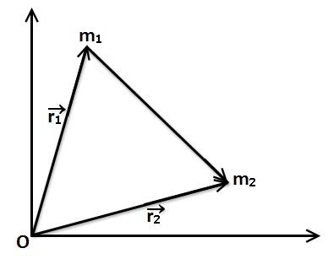
2. Two particles $m_{1}$ and $m_{2}$ are placed as shown in the figure. The gravitational force on $m_{2}$ because of $m_{1}$ will be along
$\vec{r_{1}}-\vec{r_{2}}$

$\vec{r_{2}}-\vec{r_{1}}$

3. The significance of negative sign in the universal law of gravitation is that
   1. force is negative.
   2. force is attractive.
   3. force is repulsive.
   4. None of the above.

##### self assessment

|  |  |  |  |  |
| --- | --- | --- | --- | --- |
| Total Qs. |  | Correctly solved | Attempted | Not Attempted |
| 10 | Individually |  |  |  |
| After GD |  |  |  |

#### C:\Users\Avanti\Documents\Typing\Shubhamn\26th Aug\7a.jpgIn-Class Exercise 1

1. In the given figure a square of edge length 20.0 cm is formed by four spheres of masses $m_{1}=5.00 g, m_{2}=3.00 g, m_{3}=1.00 g$, and $m_{4}=5.00 g$. In unit-vector notation, what is the net gravitational force from them on a central sphere with mass $m_{5}=2.00 g?$
2. 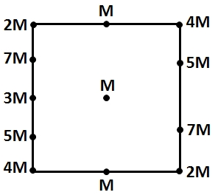Calculate the force that the earth exerts on the object of mass 1 kg kept on the surface of it. Given: mass of the earth = 6 x 1024 kg and radius of the earth = 6400 km. (Note: For a spherical body, the whole mass is assumed to be concentrated at its geometric centre)
3. A central particle of mass $M$ is surrounded by a square array of other particles, separated by either distance $d$ or distance $d/2$ along the perimeter of the square. What are the magnitude and direction of the net gravitational force on the central particle due to the other particles?

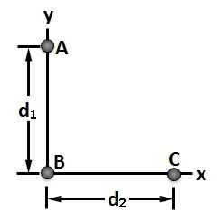

1. In the given figure, three 8 kg spheres are located as shown in the figure with $d_{1}=0.3$ m and $d_{2}=0.4$ m. What are the (a) magnitude and (b) direction (relative to the positive direction of the $x$ axis) of the net gravitational force on sphere $B$ due to spheres $A$ and $C?$

**IN-CLASS EXERCISE 2**

1. A satellite is orbiting the earth at a height of $6R$ above the surface of the earth with time period of 24 hours; $R$ being the radius of the earth. What will be the time period of another satellite at a height $2.5 R$ from the surface of the earth?
2. A double star system consists of two stars $A$ and $B$ which have time periods $T_{A}$ and $T_{B}$. Radius $R_{A}$ and $R_{B}$ and mass $M_{A}$ and $M_{B}$. Choose the correct option.
   1. If $T_{A}>T_{B} then R_{A}>R_{B}$
   2. If $T_{A}>T_{B} then M_{A}>M_{B}$
${\left(T_{A}/T_{B}\right)}^{2}={\left(R_{A}/R_{B}\right)}^{3}$

$T_{A}=T_{B}$

3. Imagine a light planet revolving around a very massive star in a circular orbit of radius $R$ with a period of revolution $T$. If the gravitational force of attraction between the planet and the star is proportional to $R^{-5/2}$, then $T^{2}$ is proportional to
$R^{2}$

$R^{\frac{7}{2}}$

$R^{\frac{3}{2}}$

$R^{3.75}$

4. A particle of mass $m_{1}=0.67$ kg is kept at a distance $d=0.5$ m from one end of a uniform rod with length $L=2.5$ m and mass $M=4.0$ kg. What is the magnitude of the gravitational force $\vec{F}$ on the particle from the rod?

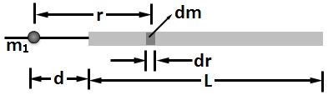

##### self assessment

|  |  |  |  |  |
| --- | --- | --- | --- | --- |
| Total Qs. |  | Correctly solved | Attempted | Not Attempted |
| 8 | Individually |  |  |  |
| After GD |  |  |  |

#### Homework

###### Level 1

1. Find the force that a 1 kg body exerts on another 1 kg object kept at a distance 1 m apart.
2. What must be the separation between a 5.2 kg particle and a 2.4 kg particle for their gravitational attraction to have a magnitude of $2.3×{10}^{-12} N?$
3. If the distance between the earth and the sun were half its present value, then find the number of days in a year.
4. A geostationary satellite (Time period of such a satellite equals 24 hours) orbits around the earth in a circular orbit of radius $36, 000$ km. Then, what will be the time period of a spy satellite orbiting a few hundred km above the earth’s surface $\left(R_{e}=6400 km\right)$.
5. In Kepler’s 3rd law, $T^{2}$ is proportional to $R^{3}$. What is the proportionally constant to be multiplied with the later?
6. A sphere of mass 40 kg is attracted by a second sphere of mass 15 kg, when their centres are 20 cm apart, with a force of 0.1 milligram weight. Calculate the value of gravitational constant.
7. The distance of planet Jupiter from the Sun is 5.2 times that of the Earth. Find the period of revolution of Jupiter around the Sun.
8. 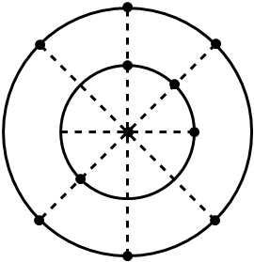Two identical copper spheres of radius $R$ are in contact with each other. If the gravitational attraction between them is $F$, find the relation between $F$ and $R$.

###### Level 2

1. In the given figure, a central particle is surrounded by two circular rings of particles, at radii $r$ and $R$, with $R>r$. All the particles have mass $m$. What are the magnitude and direction of the net gravitational force on the central particle due to the particles in the rings?
2. Two particles, of masses $m$ and $2m$, are fixed in place on an axis. (a) Where on the axis can a third particle of mass $3m$ be placed (other than at infinity) so that the net gravitational force on it from the first two particles is zero (b) Does the answer change if the third particle has, instead, a mass of $16m$? (c) Is there a point off the axis (other than infinity) at which the net force on the third particle would be zero?

C:\Users\Avanti\Documents\Typing\Shubhamn\26th Aug\4.jpg

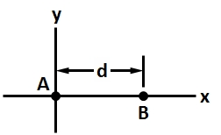

1. Two point particles are fixed on $x$ axis separated by distance $d$. Particle $A$ has mass $m_{A}$ and particle $B$ has $3m_{A}$. A third particle $C$, of mass $75m_{A}$, is to be placed on the $x$ axis near particles $A$ and $B$. In terms of distance $d,$ at what $x$ coordinate should $C$ be placed so that the net gravitational force on particle $A$ from particle $B$ and $C$ is zero?

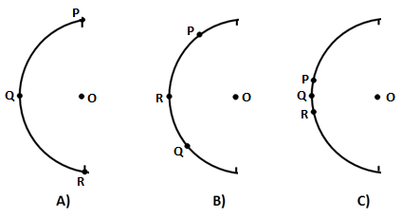

1. Figure shows three arrangements of the same identical particles P, Q, R and O with three of them placed on a circle of radius 0.20 m and the fourth one placed at the centre of the circle. (a) Rank the arrangements according to the magnitude of the net gravitational force on the central particle due to the other three particles, greatest first.
2. We want to position a space probe along a line that extends directly towards the Sun in order to monitor solar flares. How far from Earth’s centre is the point on the line where the Sun’s gravitational pull on the probe balances Earth’s pull?
3. Galileo is often credited with the early discovery of four of Jupiter's many moons. The moons orbiting Jupiter follow the same laws of motion as the planets orbiting the sun. One of the moons is called Io - its distance from Jupiter's centre is 4.2 *units* and it orbits Jupiter in 1.8 Earth-days. Another moon is called Ganymede; it is 10.7 units from Jupiter's centre. Make a prediction of the period of Ganymede using Kepler's law of harmonies (Commonly known as Law of Periods).
4. 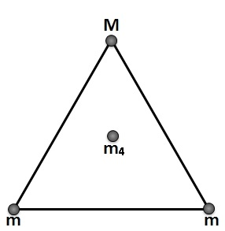The average orbital distance of Mars is 1.52 times the average orbital distance of the Earth. Knowing that the Earth orbits the Sun in approximately 365 days, use Kepler's law of harmonies to predict the time for Mars to orbit the Sun.
5. As shown in the given figure, two spheres of mass $m$ and a third sphere of mass $M$ form an equilateral triangle, and a forth sphere of mass $m_{4}$ is at the centre of the triangle. The net gravitational force on that central sphere from the three other spheres is zero. (a) What is $M$ in terms of $m$? (b) If we double the value of $m_{4}$, then what is the magnitude of the net gravitational force on the central sphere?
6. In the given figure, three particles are fixed in place as shown. The mass of $B$ is greater than the mass of $C$. Can a fourth particle (particle $D$) be placed somewhere so that the net gravitational force on particle $A$ due to particles $B, C,$ and $D$ is zero? If so, in which quadrant should it be placed and which axis should it be near?

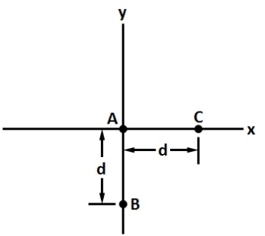

###### C:\Users\Avanti\Documents\Typing\Shubhamn\26th Aug\6.jpgLevel 3

1. Figure shows three particles initially fixed in places as shown, with $B$ and $C$ identical and positioned symmetrically about the $y$ axis, at a distance $d$ from $A$. (a) In what direction is the net gravitational force ${\vec{F}}_{net}$ acting on $A$? (b) If we move $C$ directly away from the origin, Does ${\vec{F}}_{net}$ change in direction? If so, how and what is the limit of the change?
2. A mass $M$ is split into two parts, $m$ and $M-m$, which are then separated by a certain distance. What ratio $m/M$ maximizes the magnitude of the gravitational force between the parts?
3. 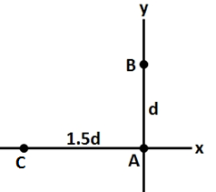In the given figure, three point particles are fixed in places in an $xy$ plane as shown. Particle $A$ has mass $m_{A}$, particle $B$ has mass $2m_{A}$, and particle $C$ has mass $3m_{A}$. A fourth particle $D$, with mass $4m_{A}$, is to be placed near the other three particles. In terms of distance $d$, at what (a) $x$ coordinate and (b) $y$ coordinate should particle $D$ be placed so that the net gravitational force on particle $A$ from particles $B$, $C$, and $D$ is zero?
4. 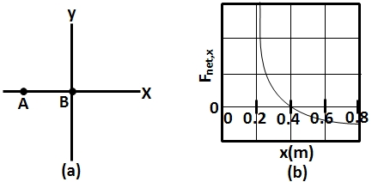Particle $A$ is fixed at $x=-0.20$ m on the $x$ axis and particle $B$, with a mass of 1.5 kg, is fixed at the origin. Particle $C$ (not shown) can be moved along the $x$ axis, between particle $B$ and $x=∞$. Figure shows the $x$ component $F_{net, x}$ of the net gravitational force on particle $B$ due to particles $A$ and $C$, as a function of position $x$ of particle $C$. The plot actually extends to the right, approaching an asymptote of $-4.17×{10}^{-10}$ N as $x→∞$. What are the masses of (a) particle $A$ and (b) particle ?
5. 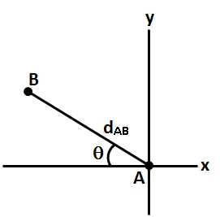Three point particles are fixed in position in an $xy$ plane. Two of them, particle $A$ of mass 6 g and particle $B$ of mass 12 g, are shown in the figure with a separation of $d_{AB}=0.5$ m at angle $θ=30°$. Particle $C$, with mass 10 g, is not shown. The net gravitational force acting on particle $A$ due to particles $B$ and $C$ is $2.77×{10}^{-14}$ N at an angle of $-143°$ from the positive direction of the $x$ axis. What are the (a) the $x$ coordinate and (b) the $y$ coordinate of particle C?
6. Three particles, each of mass $m$, are situated at the vertices of an equilateral triangle of side length $a$. The only forces acting on the particles are their mutual gravitational forces. It is desired that each particle moves in a circle while maintaining the original mutual separation $a$. Find the initial velocity that should be given to each particle and also the time period of the circular motion.
7. 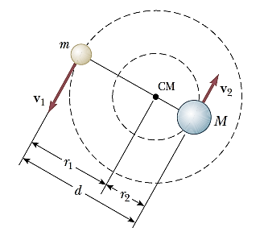Two stars of masses M and m, separated by a distance d, revolve in circular orbits about their centre of mass (see figure). Show that each star has a period given by:

$$T^{2}=\frac{4π^{2}d^{3}}{G\left(M+m\right)}$$

## 

## P7.2 Gravitational Field

Learning objectives

1. Understand the concept of gravitational field associated with gravitational force.
2. Determine the gravitational field produced by a mass at any specified point.
3. Calculate the gravitational field produced by common objects (such as disk, ring, hollow sphere, and solid sphere) as a function of distance from their centres.

#### Pre-Reading

|  |  |  |  |
| --- | --- | --- | --- |
| Category | Book Name (Edition) | Chapter | Section |
| REQUIRED | NCERT XI | 8 | 8.5 |
| ADDITIONAL | Concept of Physics, H. C. Verma | 11 | 11.6 and 11.8 |

#### Pre-Reading Exercise

1. The SI unit of gravitational field is _____________________.
2. Gravitational field is a ________________ (vector/scalar) field.
3. The intensity of gravitational field near the surface of the earth is equal to the ________________.
4. Gravitational field depends on the mass of test object (True/False).
5. Which of the following point has zero gravitational field:
6. 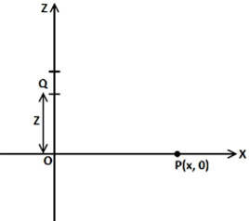A point inside hollow sphere.
7. A point at the centre of a ring.
8. A point on the surface of earth.
9. A point at the mid-point of a rod.
10. Consider a line mass distribution as shown in the figure.

I. Write the expression of $\vec{PQ}$ and $\vec{QP}$.

II. Write the expression of unit vector along $\vec{PQ}$ and $\vec{QP}$.

##### self assessment

|  |  |  |  |  |
| --- | --- | --- | --- | --- |
| Total Qs. |  | Correctly solved | Attempted | Not Attempted |
| 9 | Individually |  |  |  |
| After GD |  |  |  |

#### In-Class Exercise 1

1. A mass $M$ is kept in space uninfluenced by the other objects. Write the gravitational field at a distance $x$ from the centre of this mass in both vector and scalar form. Assume the outward direction to be positive.
2. Rocket is fired from the earth to the moon. The distance between the earth and the moon is $r$ and the mass of the earth is $81$ times the mass of the moon. Find the point on the path where the gravitational force on the rocket will be zero.
3. Two particles of mass $M$ are placed at a separation of $2a$. What will be the gravitational field at a distance $x$ from the centre of two particles?
4. Along the line joining the two masses, given $(x>a)$
5. Perpendicular to the line joining the two masses.
6. A thin rod of length $l$ and mass $M$ is placed along $z$ axis with its midpoint at origin. Find the gravitational field at $\left(0, 0, z\right)$, where $z>\frac{L}{2}$

**In-Class Exercise 2**

1. A ring of mass $M$ and radius $R$ is placed such that its plane is perpendicular to the $x$-axis and its axis co-incides with $x$-axis. Find the variation of gravitational field due to the ring along $x$-axis.
2. Find the gravitational field at the distance $x$ from the centre of the uniform solid shell of negligible thickness and mass $M$ where:
$x<R$

$x=R$

$x>R$

3. A uniform ring of mass $m$ and radius $a$ is placed directly above a uniform sphere of mass $M$ and of equal radius. The centre of the ring is at a distance $\sqrt{3}a$ from the centre of the sphere. Find the gravitational force exerted by the sphere on the ring.

##### self assessment

|  |  |  |  |  |
| --- | --- | --- | --- | --- |
| Total Qs. |  | Correctly solved | Attempted | Not Attempted |
| 7 | Individually |  |  |  |
| After GD |  |  |  |

#### Homework

###### Level 1

1. A $10 kg$ particle is kept in space uninfluenced by the other objects. Write the gravitational field at a distance $2 m$ from the centre of this particle in both vector and scalar form. Assume the outward direction to be positive.
2. Two bodies of masses $100kg$ and $10,000kg$ are at a distance $1 m$ apart. At which point on the line joining them the gravitational field intensity will be zero?
3. The gravitational field in a region is given by $\vec{E}=\left(10 N kg^{-1}\right)\left(\vec{i}+\vec{j}\right)$. Find the work done by an external agent to slowly shift a particle of mass 2 kg from the point $\left(0 m, 0 m\right)$ to a point $\left(5 m, 4 m\right).$
4. Draw the variation of gravitational field from negative infinity to positive infinity along $x$-axis for the two particle system of same mass placed at a separation of $2a$.
5. Calculate the gravitational intensity at a location which is from the surface of the earth at a height equal to 4 times the radius of the earth. $R_{e}=6400$ km
6. Find the gravitational field at the distance $x$ from the centre of the uniform solid sphere of mass $M$ where.

$x<R$

$x=R$

$x>R$

###### Level 2

1. 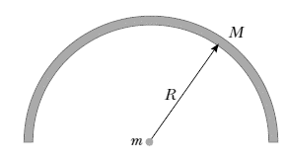Five particles each of mass $M$ are placed on the vertex of a regular hexagon of side $"a"m$. Find the force experienced by the particle of mass $m$ when placed at the 6th vertex.
2. A thin rod of length $l$ and mass $M$ is placed along $x$ axis with its midpoint at origin. Find the gravitational field at $\left(x, 0, 0\right)$
3. A uniform rod of mass M is in the shape of a semicircle of radius R as shown in the figure. Calculate the force on a point mass m placed at the centre of the semicircle.
4. A spacecraft in the shape of a long cylinder has a length of 100 m, and its mass with occupants is 1 000 kg. It has strayed too close to a 1.0-m-radius black hole having a mass 100 times that of the Sun (see figure). The nose of the spacecraft is pointing towards the centre of the black hole, and the distance between the nose and

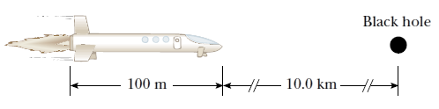the black hole is 10.0 km. (a) Determine the total force on the spacecraft. (b) What is the difference in the gravitational fields acting on the occupants in the nose of the ship and on those in the rear of the ship, farthest from the black hole?

1. For a ring of mass $M$ and radius $R$, find the point on the axis where gravitational field will be maximum. What force will be needed to keep a particle of mass $m$ at rest at that point.
2. A disk of mass $M$ and radius $R$ is placed such that its plane is perpendicular to the $x$-axis and its axis co-incides with $x$-axis. Find the variation of gravitational field due to the disk along $x$-axis.
3. The magnitude of gravitational field at a distance $r_{1}$ and $r_{2}$ from the centre of a uniform solid sphere of radius $R$ and mass $M$ are $I_{1}$ and $I_{2}$ respectively. Find the ratio of ($I_{1}$/ $I_{2}$) if $r_{1}>R$ and $r_{2}<$.
4. concentric shells of radius $R_{1}$ and $R_{2}$ and masses $, M_{1}$ and $M_{2}$ are placed with ${ R}_{1}<R_{2}$. What is the gravitational field at
5. $x=a,$ where $a<R_{1}$.
$x=b, R_{1}<b<R_{2}$

$x=c, c>R_{2}$

7. 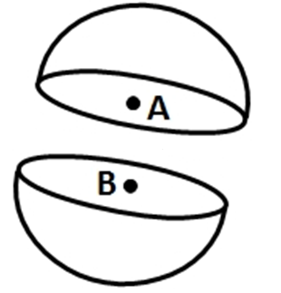A thin spherical shell having uniform density is cut into two parts by a plane and kept separated as shown in the figure. The point $A$ is the centre of the plane section of the first part and $B$ is the centre of the plane section of the second part. Show that the gravitational field at $A$ due to the first part is equal in magnitude to the gravitational field at $B$ due to the second part.

###### Level 3

1. 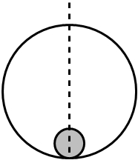A solid sphere of mass $m$ and radius $r$ is placed inside a hollow thin spherical shell of mass $M$ and radius $R$ as shown in the figure. A particle of mass $m'$ is placed on the line joining the two centres at a distance $x$ from the point of contact of the sphere and the shell. Find the magnitude of the resultant gravitational force on this particle due to the sphere and the shell if (a) $r<x<2r$, (b) $2r<x<2R$ and (c) $x>2$.
2. Find the gravitational field at the vertex of solid cone of mass $M,$ height $H$ and base radius $R$.
3. 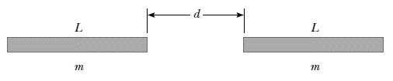Consider two identical uniform rods of length L and mass m lying along the same line and having their closest points separated by a distance d (see figure). Show that the mutual gravitational force between these rods has a magnitude:

$$F=\frac{Gm^{2}}{L^{2}}\ln\left(\frac{{\left(L+d\right)}^{2}}{d\left(2L+d\right)}\right)$$

## P7.3 Gravitational and Potential energy

Learning objectives

1. Calculate the gravitational potential energy possessed by a system of bodies.
2. Determine the gravitational potential produced by a mass at any specified point.
3. Calculate the gravitational potential produced by common objects (such as disk, ring, hollow sphere, and solid sphere) as a function of distance from their centres.
4. Determine the change in gravitational potential in a gravitational field.
5. Calculate the work done by the field as well as external force in moving an object in a gravitational field.

#### Pre-Reading

|  |  |  |  |
| --- | --- | --- | --- |
| Category | Book Name (Edition) | Chapter | Section |
| REQUIRED | NCERT XI | 8 | 8.7 |
| REQUIRED | HC Verma | 11 | 11.4 to 11.7 |

#### Pre-Reading Exercise [Do not DERIVE ANY EXPRESSION]

1. Dimension of gravitational potential is ___________________
2. Gravitational potential is a relative concept (True/False).
3. A ____________(negative/positive) gravitational potential in a planetary system signifies that the system is bound to each other.
4. Write the expression of potential due to a point mass at a distance $'r'$.
5. If the change in gravitational field between two points are zero, work done in moving a mass between those points must be zero (True/False).
6. If we restrict ourselves to $1$-D only then which of the following statement is true.
7. $\vec{F}=\frac{-dv}{dx} \hat{i} ;$ for any force
8. $\vec{F}=-\frac{dv}{dx} \hat{i} ;$ for conservative forces only.
9. Gravitational potential due to a given mass distribution
10. always increases with distance
11. always decreases with distance
12. can decrease or increase with distance

[Hint: - The gravitational force is always attractive]

##### self assessment

|  |  |  |  |  |
| --- | --- | --- | --- | --- |
| Total Qs. |  | Correctly solved | Attempted | Not Attempted |
| 7 | Individually |  |  |  |
| After GD |  |  |  |

#### In-Class Exercise 1

1. Find the potential energy of a two particle system of masses $M$ and $m$ kept at $r$ distance apart. Also, derive the expression for the potential of the particle of mass $M$ at a distance $r$ from it.
2. A mass $M$ is split into 2 parts, $m$ and $M-m$ which are then separated by a certain distance. What ratio $m/M$ gives the least gravitational potential energy for the system?
3. Three identical particles of mass $m$ and radius $r$ are brought from infinity to form an equilateral triangle of side $a$ m. Find the work done by the external force in doing so.
4. What is the variation of potential due to a uniform circular ring of mass $M$ and radius $R$ along the axis of the ring?

**In-Class Exercise 2**

1. 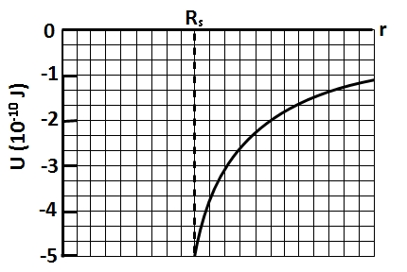Calculate the gravitational potential of a solid sphere of uniform density at a) $r>R$ b) $<R$; where $R$ is the radius of the sphere. Assume the mass of the sphere is $M$.
2. Figure gives the potential energy function $U\left(r\right)$ of a projectile, plotted outward from the surface of a planet of radius $R_{s}.$ If the projectile is launched radially outward from the surface with a mechanical energy of $-2.0×10^{9} J$, what are (a) its kinetic energy at radius $r=2 R_{s}$ and (b) its turning point (the point at which its reverses its direction of motion ) in terms of $R_{s}$?
3. The gravitational potential in a region is given by $V=20 Nkg^{-1}\left(x+y\right).$ a) show that the equation is dimensionally correct. b) Find the gravitational field at the point (x, y). Leave your answer in terms of the unit vectors $\vec{i}, \vec{j}, \vec{k}$. c) Calculate the magnitude of the gravitational force on a particle of mass $500g$ placed at the origin.

##### self assessment

|  |  |  |  |  |
| --- | --- | --- | --- | --- |
| Total Qs. |  | Correctly solved | Attempted | Not Attempted |
| 7 | Individually |  |  |  |
| After GD |  |  |  |

#### Homework

###### Level 1

1. (a) What is gravitational potential energy of the two-particle system of masses $5.2 kg$ and $2.4 kg$, given that the gravitational force between them is $2.3×{10}^{-12} N$? If you triple the separation between the particles, how much work is done (b) by the gravitational force between the particles and (c) by you?
2. 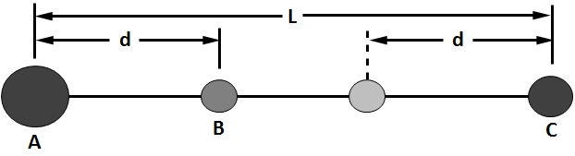The three spheres as shown in the figure with masses $m_{A}=80 g$, $m_{B}=10$ g, $m_{c}=20 g$, have their centres on a common line, with $L=12 cm$ and $d=4.0 cm$. You move sphere $B$ along the line until its centre-to-centre separation from $C$ is $d=4.0 cm.$ How much work is done on sphere $B$ (a) by you and (b) by the net gravitational force on $B$ due to spheres $A$ and $C$?
3. 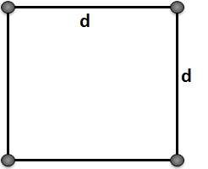Figure shows four particles, each of mass $20.0 g$, that form a square with an edge length of $d=0.600 m.$ If $d$ is reduced to $0.200 m$, what is the change in the gravitational potential energy of the four-particle system?
4. 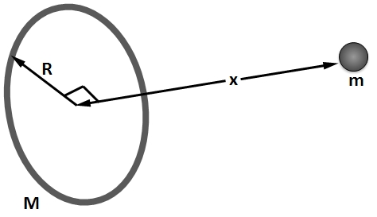Consider a homogeneous thin ring of mass $M$ and outer radius $R$ as shown in figure. Suppose a particle falls from rest from a distance $x$ along the axis as result of the attraction of the ring of matter. What is the speed with which it passes through the centre of the ring?
5. Calculate the potential due to a uniform circular disk of radius $R$ and mass $M$ at a point on its axis at a distance $z$ from the centre.
6. The gravitational field due to a mass distribution is given by $E=k/x^{3}$ in x direction. Taking the gravitational potential to be zero at infinity, find its value at a distance $x$.

###### Level 2

1. The gravitational potential due to a mass distribution is $V=\frac{A}{\sqrt{A^{2}+x^{2}}}$, where A is a constant. Find the variation in the gravitational field with .
2. Calculate the potential at a distance $z$ from centre on the axis of a non-uniform disk of radius $R$ if the density of disk varies linearly along radius of disk, $r$ as $ρ=ρ_{o}\left(1+\frac{r}{R}\right)$
3. Calculate the potential of the spherical shell of uniform density and negligible thickness at a) $r>R$ b) $<R$; where $R$ is the radius of the shell. Assume the mass to be $M$. Also draw the gravitational potential versus position curve.
4. Alpha, a hypothetical planet, has mass of $5.0×10^{23} kg$, a radius of $3.5 ×10^{6}$ m, and no atmosphere. A $10 kg$ space probe is to be launched vertically from its surface. (a) If the probe is launched with an initial energy of $5.0×10^{7} J$, what will be its kinetic energy when it is $4.0×10^{6}$ m from the centre of Alpha? (b) If the probe is to achieve a maximum distance of $8.0×10^{6} m$ from the centre of Alpha, with what initial kinetic energy must it be launched from the surface of Alpha?
5. In deep space, sphere $A$ of mass $20$ kg is located at the origin of an $x$ axis and sphere $B$ of mass $10 kg$ is located on the axis at $x=1 m$. Sphere $B$ is released from rest while sphere $A$ is held at the origin. (a) What is the gravitational potential energy of the two-sphere system just as $B$ is released? What is the kinetic energy of $B$ when it has moved $0.2 m$ toward $A$?
6. A spherical asteroid whose radius is $500 km$ and whose gravitational acceleration at the surface is $3.0 m/s^{2}$ (a) How far from the surface will a particle go if it leaves the asteroid’s surface with a radial speed of $1000 m/s$? (c) With what speed will an object hit the asteroid if it is dropped from $1000 km$ above the surface?
7. Two neutron stars are separated by a distance of $1.0×10^{10}$ m. Each have a mass of $1.0×10^{30} kg$ and a radius of $1.0×10^{5} m.$ They are initially at rest with respect to each other. As measured from the rest frame, how fast are they moving when
8. their separation has decreased to one-half its initial value and
9. they are about to collide?

###### Level 3

1. Four uniform spheres, with masses $m_{A}=40 kg, m_{B}=35$ kg, $m_{c}=200$ kg, and $m_{D}=50 kg$, have $\left(x, y\right)$ coordinates of $\left(0, 50 cm\right),$ $\left(0, 0\right), \left(-80 cm, 0\right), and \left(40 cm, 0\right),$ respectively. What is the net gravitational potential at the origin due to the other spheres?
2. In the above problem, remove sphere $A$ and calculate the gravitational potential energy of the remaining three-particle system. (b) If $A$ is then put back in place, is the potential energy of the four-particle system more or less than that of the system in (a)? (c) In (a), is the work done by you to remove $A$ positive or negative? (d) In (b), is the work done by you to replace $A$ positive or negative?
3. The gravitational field in a region is given by $\vec{E}=(5 N/kg)\hat{i} +(12 N/kg)\hat{j}$. a) Find the magnitude of the gravitational force on a particle of mass $2 kg$ placed at the origin. b) Find the potential at the points (12, 0) and (0, 5) if the potential at the origin is taken to be zero. c) Find the change in the gravitational potential energy if a particle of mass $2 kg$ is taken from origin to the point (12, 5). d) Find the change in potential energy if the particle is taken from (12, 0) to (0, 5).
4. Figure is a graph of the kinetic energy $K$ of an asteroid versus its distance $r$ from Earth’s centre, as the asteroid falls directly in toward that centre. (a) What is the (approximately) mass of the asteroid? What is its speed at $r=1.945×10^{7}$ m?

[Caution: The curve is not a straight line].

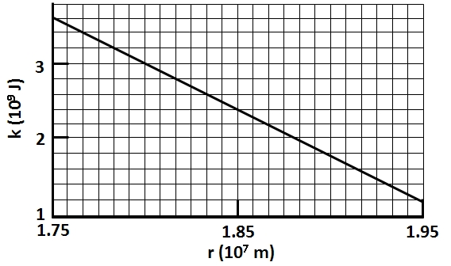

1. Figure shows a particle $A$ that can be moved along $y$ axis from an infinite distance to the origin. That origin lies at the midpoint between particles $B$ and $C$, which have identical masses, and then $y$ axis is a perpendicular bisector between them, distance $D$ is $0.3057$ m. Figure shows the potential energy $U$ of the three-particle system as a function of the position of particle $A$ along the $y$ axis/ The curve actually extends rightward and approaches an asymptote of $-2.0×10^{-11} J$ as $y→∞$. What are the masses of (a) particle $B$ and $C$ and (b) particle A?

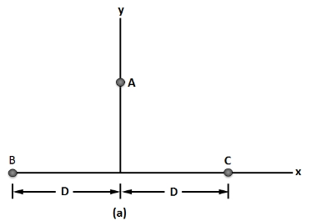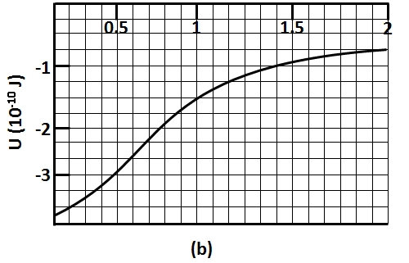

1. Write the expression of gravitational potential due to a ring of radius $R$ at a point on its axis placed very close to the centre.

## P7.4 Earth’s Gravity

Learning objectives

1. Determine the variation of acceleration due to gravity with
   * Altitude
   * Depth
   * Rotation of the Earth
   * Shape of the Earth
2. Calculate the acceleration due to gravity at a given location with respect to the earth’s surface.
3. Calculate the kinetic and potential energy of particle at any height above the earth’s surface.
4. Calculate the escape speed of a particle from a given location.

#### Pre-Reading

|  |  |  |  |
| --- | --- | --- | --- |
| Category | Book Name (Edition) | Chapter | Section |
| REQUIRED | NCERT XI | 8 | 8.5, 8.6 and 8.8 |
| ADDITIONAL | HC Verma | 11 | 11.3, 11.9 and 11.14 |

#### Pre-Reading Exercise

1. 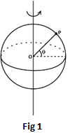The force of gravitation due to the earth on a mass $'m'$ placed at a distance $h$ from the surface is given by $F=\frac{GMm}{{\left(R+h\right)}^{2}}$
   1. What is the range of $h$? [Hint- What is the gravitational field due to a solid sphere]
   2. Plot $F$ vs $h$
2. What is the colatitude of the point $P$ shown in the figure 1.
3. Draw the FBD of a particle placed on the earth at colatitude $'θ'$ with respect to the earth’s frame of reference. Take pseudo-forces in account.
4. To derive the expression of escape velocity for a planet, which of the following conservation law is used?
   1. Conservation of momentum.
   2. Conservation of angular momentum.
   3. Conservation of energy.
   4. Conservation of mass.
5. What is the minimum velocity with which a body, if thrown, will never return back to the earth?
6. Using the fact that the force exerted on any body at the surface of the earth is $\frac{GMm}{R_{E}^{2}}$;

Where $M=$ mass of the earth $=6×10^{24} kg$

$m=$ mass of the body.

$G=6.67×10^{-11} \frac{Nm^{2}}{kg^{2}}$

$R_{E}=6.4×10^{3} km.$

Find the value of $'g'$

1. Write the mass of the earth in the terms of its radius $\left(R_{E}\right)$ and density $\left(ρ\right).$

##### self assessment

|  |  |  |  |  |
| --- | --- | --- | --- | --- |
| Total Qs. |  | Correctly solved | Attempted | Not Attempted |
| 7 | Individually |  |  |  |
| After GD |  |  |  |

#### In-Class Exercise 1

1. Find the escape velocity from the surface of the earth for any particle. Given the mass of the earth is $M=6×{10}^{24}kg$ and $R=6400 km$.
2. The masses and radii of the earth and moon are $M_{1}$ and $M_{2}$ and $R_{1}$ and $R_{2}$ respectively. Their centres are at a distance r $.$ Find the minimum speed with which the particle of mass $m$ should be projected from a point midway between the two centres so as to escape to infinity.
3. What is the acceleration due to gravity at a height $h$ ($h≪R$) above the earth’s surface. Given that the acceleration due to gravity on the surface of the earth is $g$.
4. ****What is the acceleration due to gravity at a depth $d$ ($d≪R$) below the earth’s surface. Given that the acceleration due to gravity on the surface of the earth is $g$.

**In-Class Exercise 2**

1. Figure gives the potential energy function $U\left(r\right)$ of a projectile, plotted outward from the surface of a planet of radius $R_{s}$. What least kinetic energy is required of a projectile launched at the surface if the projectile is to “escape” the planet.
2. Find the weight of a man of mass $M$ at the latitude $θ$. Given that the angular velocity of the earth is $ω$.
3. A pendulum having a bob of mass $m$ is hanging in a ship sailing along the equator from east to west. When the ship is stationary with respect to water the tension in the string is $T_{0}$. (a) Find the speed of the ship due to rotation of the earth about its axis. (b) Find the difference between $T_{0}$ and the earth’s attraction on the bob, (c) If the ship sails at speed $v$, what is the tension in the string? Angular speed of earth’s rotation is $ω$ and radius of the earth is $R$.

##### self assessment

|  |  |  |  |  |
| --- | --- | --- | --- | --- |
| Total Qs. |  | Correctly solved | Attempted | Not Attempted |
| 7 | Individually |  |  |  |
| After GD |  |  |  |

#### Homework

###### Level 1

1. A particle is fired vertically upward with a speed of $9.8 km s^{-1}$. Find the maximum height attained by the particle. Radius of earth $=6400$ km and $g$ at the surface $=9.8 m s^{-2}$. Consider only earth’s gravitation.
2. A tunnel is dug along a diameter of the earth. Find the force on a particle of mass $m$ placed in the tunnel at a distance $x$ form the centre.
3. A body is projected vertically upwards from the surface of the earth so as to reach a height equals to the radius of the earth. Neglecting resistance due to air, calculate the initial speed which should be imparted to the body. Given: $Mass of earth=6×{10}^{24}kg$; $Radius of earth=6400 km$.
4. Find the height over the earth’s surface at which the weight of a body becomes half of its value at the surface.
5. A body is weighed by a spring balance to be 1 kg at the North Pole. How much will it weigh at the equator? Account for the earth’s rotation only.
6. What is the acceleration due to gravity on the top of Mount Everest? Mount Everest is the highest mountain peak of the world at the height of 8848 m. ‘g’ at sea level is 9.80 m $s^{-2}.$ (Hint: Calculate Approx value)
7. Find the acceleration due to gravity in a mine of depth 640 m if the value at the surface is 9.8 $m s^{-2}$. The radius of the earth is 6400 km. (Hint: Calculate Approx value)
8. A mass of $6×{10}^{24}$ kg (equal to the mass of the earth) is to be compressed in a sphere in such a way that the escape velocity form its surface is $3×{10}^{8} m s^{-1}$. What should be the radius of the sphere?

###### Level 2

1. The escape speed of the projectile on the surface of the earth is $11.2 km/s$. If a body is projected out with twice of this speed, find the speed of the body far away from the earth. Ignore the presence of other planets and sun.
2. A tunnel is dug along a chord of the earth at a perpendicular distance $R/2$ from the earth’s centre. The wall of the tunnel may be assumed to be frictionless. Find the force exerted by the wall on a particle of mass $m$ when it is at a distance of $x$ from the centre of the tunnel.
3. What will a man of mass $70 kg$ weighs at a latitude a) ${30}^{0}$ b) ${60}^{0}$
4. A body stretches a spring by a particular length at the earth’s surface at equator. At what height above the South Pole will it stretch the same spring by the same length? Assume the earth to be spherical.
5. At what rate should the earth rotate so that the apparent $g$ at the equator becomes zero? What will be the length of the day in this situation?
6. The moon takes about 27.3 days to revolve around the earth in a nearly circular orbit of radius $3.84×{10}^{5}$ km. Calculate the mass of the earth from these data.
7. The mass of the earth is $6×{10}^{24}kg$ and its radius is $6400 km$. How much work will be done in taking a $10kg$ body from the surface of the earth to infinity? What will be the potential energy of the body on the earth’s surface?
8. A satellite of mass 1000 kg is supposed to orbit the earth at a height of 2000 km above the earth’s surface. Find (a) its speed in the orbit, (b) its kinetic energy, (c) the potential energy of the earth-satellite system and (d) its time period. Mass of the earth $=6×{10}^{24}$ kg.
9. (a) Find the radius of the circular orbit of a satellite moving with an angular speed equal to the angular speed of earth’s rotation. (b) If the satellite is directly above the North Pole at some instant, find the time it takes to come over the equatorial plane. Mass of the earth $=6×{10}^{24}$ kg.
10. A particle is fired vertically upward from earth’s surface and it goes up to a maximum height of 6400 km. Find the initial speed of particle.
11. A rocket is fired vertically from the surface of the Mars with a speed of $2 km/s$. If $20\%$ of its initial kinetic energy is lost due to the atmospheric resistance, how far will the rocket go from the surface of Mars before returning to it. Mass of Mars $=6.4×{10}^{23}kg$; Radius of Mars $=3395 km$.
12. The earth has a mass nine times and radius twice that of the planet Mars. Calculate the maximum speed required by a rocket to pull out of the gravitational force of Mars. Given escape speed on the surface of the earth is $11.2 km/s$.

###### Level 3

1. The radius of the earth shrinks by 2%. Find the percentage change in a) acceleration due to gravity b) escape Velocity.
2. A projectile is shot directly away from Earth’s surface. Neglect the rotation of Earth. What multiple of Earth’s radius $R$ (given the radial distance) a projectile reaches if (a) Its initial speed is $0.500$ of the escape speed from Earth and (b) Its initial kinetic energy is $0.500$ kinetic energy required to escape Earth? (c) What is the least initial mechanical energy required at launch if the projectile is to escape Earth?
3. Assume a planet has a uniform sphere of radius $R$ that has a narrow tunnel through its centre. Also assume we can position an apple anywhere along the tunnel or outside the sphere. Let $F$ be the magnitude of gravitational force on the apple when it is located at the planet’s surface. a) Describe the motion of the apple if it is dropped from the surface. How far from the surface is there a point where the magnitude of gravitational force on the apple is $F/3$ if we move the apple b) away from the surface, c) into the tunnel?

## P7.5 Satellite and Orbits

Learning objectives

1. Determine the relation between the energy of an orbiting satellite and the radius of their orbit.
2. Determine the position of geostationary and polar satellites.
3. Relate the time period of orbiting satellite with their radius of orbit.
4. Calculate the orbital velocity, the time period and the energy of a satellite.
5. Define weightlessness and understand the concept of it.

#### Pre-Reading

|  |  |  |  |
| --- | --- | --- | --- |
| Category | Book Name (Edition) | Chapter | Section |
| REQUIRED | NCERT XI | 8 | 8.9 to 8.12 |
| ADDITIONAL | - | - | - |

#### Pre-Reading Exercise

1. The motion of a satellite is $________________$ (acceleration/unaccelarated)
2. For a satellite in stable orbit, the centripetal force is equal to the gravitational force. (True/False)
3. The total energy of a satellite in a circular orbit is positive. (True/False)
4. The kinetic energy of a satellite in a circular orbit is positive. (True/False)
5. The potential energy of a satellite in a circular orbit is positive. (True/False)
6. A satellite is always visible from a point on earth, then it is a $____________________$ satellite.
7. Draw the FBD of a satellite in the earth’s frame of ref. moving in a circular orbit around the earth. Assume that the earth is not rotating.
8. $_______________$ of an object is the force which the earth attracts it.
9. Draw the FBD of an object at rest placed inside a satellite with
10. Satellite as reference frame.
11. Earth as reference frame.

##### self assessment

|  |  |  |  |  |
| --- | --- | --- | --- | --- |
| Total Qs. |  | Correctly solved | Attempted | Not Attempted |
| 9 | Individually |  |  |  |
| After GD |  |  |  |

#### In-Class Exercise 1

1. Two Earth satellites, $A$ and $B$, each of mass $m$, are to be launched into circular orbits about Earth’s centre. Satellite $A$ is to orbit at an altitude of 6370 km. Satellite $B$ is to orbit at an altitude of 19 850 km. The radius of Earth $R_{E}$ is 6370 km. (a) What is the ratio of the potential energy of satellite $B$ to that of satellite $A$, in orbit? (b) What is the ratio of the kinetic energy of satellite $B$ to that of satellite $A$, in orbit? (c) Which satellite has the greater total energy if each has a mass of 14.6 kg? (d) By how much?
2. A satellite orbits a planet of unknown mass in a circle of radius $3.0×{10}^{7}$ m. The magnitude of the gravitational force on the satellite from the planet is $F=80 N.$ (a) What is the kinetic energy of the satellite in this orbit? (b) What would $F$ be if the orbit radius were increases to $4.0×{10}^{7}$ m?
3. A satellite is in a circular Earth orbit of radius $r$. The area $A$ enclosed by the orbit depends on $r^{2}$ because $A=πr^{2}$. Determine how the following properties of the satellite depend on $r$: (a) period, (b) kinetic energy, (c) angular momentum, and (d) speed.

#### In-Class Exercise 2

1. 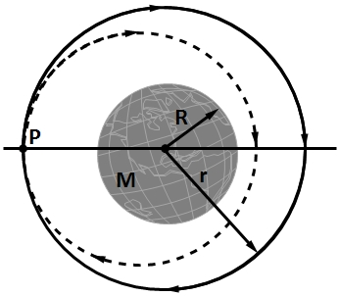Two small spaceships, each with mass $m=1500$ kg, are in the circular Earth orbit (see figure) at an altitude $h$ of 400 km. Igor, the commander of one of the ships, arrives at any fixed point in the orbit 90 s ahead of Picard, the commander of the other ship. What are the (a) period $T_{0}$ and (b) speed $v_{0}$ of the ships? At point $P$ in the figure, Picard fires an instantaneous burst in the forward direction, reducing his ship’s speed by 1.00 %. After this burst, he follows the elliptical orbit shown dashed in the figure. What are the (c) kinetic energy and (d) potential energy of his ship immediately after the burst? In Picard’s new elliptical orbit, what are (e) the total energy $E$, (f) the semi major axis $a$, and (g) the orbital period $T$? (h) How much earlier than Igor will Picard return to $P$?
2. The orbit of Earth around the Sun is *almost* circular: The closest and farthest distances are $1.47×{10}^{8}$ km and $1.52×{10}^{8}$ km respectively. Determine the corresponding variations in (a) total energy, (b) gravitational potential energy, (c) kinetic energy, and (d) orbital speed. (*Hint*: Use conservation of energy and conservation of angular momentum.)
3. Two satellites $S_{1}$ and $S_{2}$ revolve around a planet in coplanar circular orbits in the same sense. Their period of revolution are $1 h$ and $8 h$ respectively. The radius of the orbit of $S_{1}$ is ${10}^{4}km$. When $S_{2}$ is closest to $S_{1}$, find A) the speed of $S_{2}$ relative to $S_{1}$ and B) the angular speed of $S_{2}$ as observed by an astronomer in $S_{1}.$

##### self assessment

|  |  |  |  |  |
| --- | --- | --- | --- | --- |
| Total Qs. |  | Correctly solved | Attempted | Not Attempted |
| 5 | Individually |  |  |  |
| After GD |  |  |  |

#### Homework

###### Level 1

1. (a) At what height above Earth’s surface is the energy required to lift a satellite to that height equal to the kinetic energy required for a satellite to be in orbit at that height? (b) For greater height, which is greater, the energy for lifting or the kinetic energy for orbiting?
2. An asteroid, whose mass is $2.0×{10}^{-4}$ times the mass of the earth, revolvs in a circular orbit around the Sun at a distance that is twice the earth’s distance from the Sun. (a) Calculate the time period of revolution of the asteroid in years. (b) What is the ratio of the kinetic energy of the asteroid to the kinetic energy of the earth?
3. A satellite is to revolve around the earth in a circle of radius $8000 km$. With what speed should this satellite be projected into the orbit? What will be the time period? Take $g$ on the surface to be $9.8 m/s^{2}$ and radius of the earth $=6400km$.
4. A satellite is in elliptical orbit with a period of $8.00×{10}^{4}$ s about a planet of mass $6.20×{10}^{24}$ kg. At aphelion, at radius $4.5×{10}^{7}$ m, the satellite’s angular speed is $7.158×{10}^{-5}$ rad/s. What is its angular speed at perihelion?
5. A 50 kg satellite orbits planet Cruton every 5.0 h. The magnitude of the gravitational force exerted on the satellite by Cruton is $85$ N. (a) What is the radius of the orbit? (b) What is the kinetic energy of the satellite? (c) What is the mass of planet Cruton?

###### Level 2

1. One way to attack a satellite in Earth orbit is to launch a swarm of pellets in the same orbit as the satellite but in the opposite direction. Suppose a satellite, in a circular orbit 500 km above Earth’s surface, collides with a pellet having mass 5.0 g. (a) What is the kinetic energy of the pellet in the reference frame of the satellite just before the collision? (b) What is the ratio of this kinetic energy to the kinetic energy of a 5.0 g bullet from a modern army riffle with a muzzle speed of 950 m/s?
2. 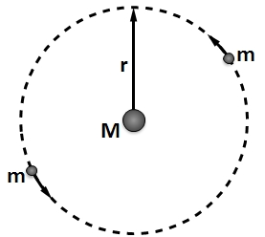What are (a) the speed and (b) the period of a 220 kg satellite in an approximately circular orbit 640 km above the surface of Earth? Suppose the satellite loses mechanical energy at the average rate of $1.4×{10}^{5}$ J per orbital revolution. Adopting the reasonable approximation that the satellite’s orbit becomes a “circle of slowly diminishing radius,” determine the satellite’s (c) altitude, (d) speed, and (e) period at the end of its 1500th revolution. (f) What is the magnitude of the average retarding force on the satellite? Is angular momentum around Earth’s centre conserved for (g) the satellite and (h) the satellite $–$ Earth system (assuming that system is isolated)?
3. A certain triple-star system consists of two stars, each of mass $m$, revolving in the same circular orbit of radius $r$ around a central star of mass $M$ (see figure). The two orbiting stars are always at opposite ends of a diameter of the orbit. Derive an expression for the period of revolution of the stars.
4. We watch two identical astronomical bodies $A$ and $B$, each of mass $m$, fall toward each other from rest because of the gravitational force on each from the other. Their initial centre-to-centre separation is $R_{i}$. Assume that we are in an inertial reference frame that is stationary with respect to the centre of mass of this two-body system. Use the principle of conservation of mechanical energy $\left(K_{f}+U_{f}=K_{i}+U_{i}\right)$ to find the following when the centre-to-centre separation is $0.5R_{i}$: (a) the total kinetic energy of the system, (b) the kinetic energy of each body, (c) the speed of each body relative to us, and (d) the speed of body $B$ relative to both $A$.

Next assume that we are in a reference frame attached to body $A$ (we ride on the body). Now we see body $B$ fall from rest toward us. From this reference frame, again use $K_{f}+U_{f}=K_{i}+U_{i}$ to find the following when the centre-to-centre separation is $0.5R_{i}$: (e) the kinetic energy of body $B$ and (f) the speed of body $B$ relative to body $A$. (g) Why are the answers to (d) and (f) different? Which answer is correct?

###### Level 3

1. If a satellite is revolving around a planet of mass $M$ in an elliptical orbit of semi-major axis $a$, show that the orbital speed of the satellite when it is at a distance $r$ from the focus will be given by
$$v^{2}=GM\left[\frac{2}{r}-\frac{1}{a}\right]$$

2. 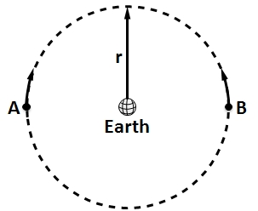In the given figure, two satellites, $A$ and $B$, both of mass $m=150$ kg, move in the same circular orbit of radius $r=7.87×{10}^{6}$ m around Earth but in opposite senses of rotation and therefore on a collision course. (a) Find the total mechanical energy $E_{A}+E_{B}$ of the two satellites + Earth system before the collision. (b) If the collision is completely inelastic so that the wreckage remains as one piece of tangled material (mass $=2m$), find the total mechanical energy immediately after the collision. (c) Just after the collision, is the wreckage falling directly toward Earth’s centre or orbiting around Earth?
3. In a shuttle craft of mass $m=3000$ kg, Captain Janeway orbits a planet of mass $M=9.50×{10}^{24}$ kg, in a circular orbit of radius $r=4.20×{10}^{7}$ m. What are (a) the orbital period of the craft and (b) the speed of the shuttle craft? Janeway briefly fires a forward-pointing thruster, reducing her speed by 2.00%. Just then, what are (c) the speed, (d) the kinetic energy, (e) the gravitational potential energy, and (f) the mechanical energy of the shuttle craft? (g) What is the semi-major axis of the elliptical orbit now taken by the craft? (h) What is the difference between period of the original circular orbit and that of the new elliptical orbit? (i) Which orbit has the smaller period?
4. In his 1865 science fiction novel *From the Earth to the Moon,* Jules Verne described how three astronauts are shot to the Moon by means of a huge gun. According to Verne, the aluminum capsule containing the astronauts is accelerated by ignition of nitrocellulose to a speed of 11 km/s along the gun barrel’s length of 220 m. (a) In $g$ units, what is the average acceleration of the capsule and astronauts in the gun barrel? (b) Is that acceleration tolerable or deadly to the astronauts?

A modern version of such gun-launched spacecraft (although without passengers) has been proposed. In this modern version, called the SHARP (Super High Altitude Research Project) gun, ignition of methane and air shoves a piston along the gun’s tube, compressing hydrogen gas that then launches a rocket. During this launch, the rocket moves 3.5 km and reaches a speed of 7.0 km/s. Once launched, the rocket can be fired to gain additional speed (c) In $g$ units, what would be the average acceleration of the rocket within the launcher? (d) How much additional speed is needed (via the rocket engine) if the rocket is to orbit Earth at an altitude of 700 km?

## Miscellaneous Objectives

Note:

* marked questions may have more than one correct option

Ϯ marked questions have integer type answer (Any one of 0, 1, 2, 3, 4, 5, 6, 7, 8, 9)

1. A very large number of particles of same mass $m$ are kept at horizontal distance of 1m, 2m, 4m, 8m… (up to infinity) from origin. The total gravitational potential at origin is
$-8Gm$

$-3Gm$

$-4Gm$

$-2Gm$

2. A hollow spherical shell is compressed to half of its radius. The gravitational potential at the centre
3. Increases
4. Decreases
5. Remains same
6. It will depend on the mass of shell
7. A satellite revolves in the geostationary orbit but in a direction east to west. The time interval between its successive passing about a point of the equator is
8. 4 h
9. 6 h
10. 12 h
11. 24 h
12. Two point masses of mass 4 $m$ and $m$ respectively separated by $d$ distance are revolving under mutual force of attraction. Ratio of their kinetic energies will be
$1:4$

$4:1$

$1:1$

$1:16$

13. A planet revolves around the sun in elliptical orbit. The aerial velocity $\left(dA/dt\right)$ of the planet is $4.0×{10}^{16} m^{2}/s.$ The least distance between planet and the sun is $2×{10}^{12}$ $m$. Then the maximum speed of the planet is $km/s$ is
14. 10
15. 20
16. 40
17. 80
18. A particle on earth’s surface is given a velocity equal to its escape velocity. Its total mechanical energy will be
    1. Negative
    2. Positive
    3. Zero
    4. Infinite
19. At what height from the surface of earth the total energy of a satellite is equal to its potential energy at a height of 2 $R$ from surface of earth? ( $R=$ radius of earth)
$2R$

$R/2$

$R/4$

$4R$

20. Two earth-satellites are revolving in the same circular orbit around the centre of the earth. They must have the same
21. mass
22. angular momentum
23. kinetic energy
24. velocity
25. A hole is drilled into the surface of the earth to its centre. A particle is dropped from rest at the surface of earth. The speed of the particle when it reaches the centre of the earth in terms of its escape velocity (on the surface of earth) $v_{e}$ is

$\frac{v_{e}}{2}$

$v_{e}$

C) $\sqrt{2} v_{e}$

$\frac{v_{e}}{\sqrt{2}}$

1. A planet has a mass of eight times the mass of the earth and its density is also equal to eight times the average density of the earth. If $g$ be the acceleration due to earth’s gravity on its surface, then acceleration due to gravity on planet’s surface will be
$2 g$

$4 g$

$8 g$

$16 g$

2. The work done in slowly lifting a body from earth’s surface to a height $R$ (radius of earth) is equal to two time the work done in lifting the same body from earth’s surface to a height $h$. Here $h$ is equal to
$\frac{R}{4}$

$\frac{R}{3}$

$\frac{R}{6}$

$\frac{R}{2}$

3. Three uniform spheres of mass $M$ and radius $R$ each are kept in such a way that each touches the other two. The magnitude of the gravitational force on any of the spheres due to the other two is
$\frac{\sqrt{3}}{4}\frac{GM^{2}}{R^{2}}$

$\frac{3}{2} \frac{GM^{2}}{R^{2}}$

$\frac{\sqrt{3} GM^{2}}{R^{2}}$



4. Figure shows the variation of energy with the orbit radius $r$ of a satellite in a circular motion. Mark the correct statement.
5. $C$ shows the total energy, $B$ the kinetic energy and $A$ the potential energy of the satellite
6. $A$ shows the kinetic energy, $B$ the total energy and $C$ the potential energy of the satellite
7. $A$ and $B$ are the kinetic and potential energies and $C$ the total energy of the satellite
8. $C$ and $A$ are the kinetic and potential energies respectively and $B$ the total energy of the satellite
9. 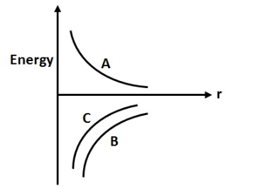If the radius of the earth were increased by a factor of 2 keeping the mass constant by what factor would its density have to be changed to keep $g$ same?
$\frac{1}{8}$

$\frac{1}{4}$

$\frac{1}{2}$

$\frac{1}{4}$

10. A satellite of mass $m$ moves along an elliptical path around the earth. The areal velocity of the satellite is proportional to
$m$

$m^{-1}$

$m^{0}$

$m^{1/2}$

11. 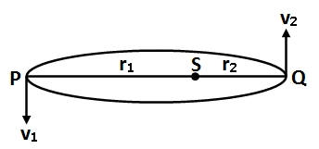A planet is moving in an elliptical path around the Sun as shown in figure. Speed of planet in position $P$ and $Q$ are $v_{1}$ and $v_{2}$ respectively with $SP=r_{1}$ and $SQ=r_{2}$, then $v_{1}/v_{2}$ is equal to
$\frac{r_{1}}{r_{2}}$

$\frac{r_{2}}{r_{1}}$

${\left(\frac{r_{2}}{r_{1}}\right)}^{2}$

${\left(\frac{r_{1}}{r_{2}}\right)}^{2}$

12. For a given density of planet the orbital period of a satellite near the surface of planet of radius $R$ is proportional to
$R^{1/2}$

$R^{3/2}$

$R^{-1/2}$

$R^{0}$

13. A person carries a mass of 2 kg from $A$ to $B$. The increase in kinetic energy of the mass is 4 J and the work done by the person on the mass is $-10 J.$ The gravitational potential difference between $B$ and $A$ is $\left(i.e., V_{B}-V_{A}\right)$
$4 J/kg$

$7 J/kg$

$-3 J/kg$

$-7 J/kg$

14. If the angular velocity of a planet about its axis is halved, the distance of geostationary satellite of this planet form the centre of the planet will become
${\left(2\right)}^{1/3} times$

${\left(2\right)}^{3/2} times$

${\left(2\right)}^{2/3} times$

$4 times$

15. A planet of mass $m$ is an elliptical orbit about the sum $\left(m≪M_{sun}\right)$ with an orbital period $T$. If $A$ be the area of orbit, then its angular momentum will be
$\frac{2mA}{T}$

$mAT$

$\frac{mA}{2T}$

$2mAT$

16. A satellite $S$ is moving in an elliptical orbit around the earth. The mass of the satellite is very small compared to the mass of the earth
17. The acceleration of $S$ is always directed towards the centre of the earth
18. The angular momentum of $S$ about the centre of the earth changes in direction, but its magnitude remain constant
19. The total mechanical energy of $S$ varies periodically with time
20. The linear momentum of $S$ remains constant in magnitude
21. 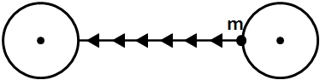Two identical spherical masses are kept at some distance as shown in the figure. Potential energy when a mass $m$ is taken from surface of one sphere to the other
22. Increases continuously
23. Decreases continuously
24. First increases then decreases
25. First decreases then increases
26. By what percent the energy of a satellite has to be increased to shift it from an orbit of radius $r$ to $\frac{3}{2} r$?
$66.7\%$

$33.3\%$

$15\%$

$20.3\%$

27. A ring has a total mass $m$ but non-uniformly distributed over its circumference. The radius of the ring is $R$. A point mass $m$ is placed at the centre of the ring. Work done in taking away this point mass form centre to infinity is
$\frac{2GmM}{R}$

$\frac{GMm}{R}$

$\frac{GMm}{2R}$

$\frac{3GMm}{2R}$

28. The angular momentum $\left(L\right)$ of earth revolving around the Sun is proportional to $r^{n}$, where $r$ is the orbital radius of the earth. The value of $n$ is (assume the orbit to be circular)
$\frac{1}{2}$

$1$

$-\frac{1}{2}$

$2$

29. The time period of an artificial satellite in a circular orbit of radius $R$ is 2 days and its orbital velocity is $v_{0}.$ If time period of another satellite in a circular orbit is 16 days then
30. Its radius of orbit is $4 R$ and orbital velocity is $v_{0}$
31. Its radius of orbit is $4 R$ and orbital velocity is $\frac{v_{0}}{2}$
32. Its radius of orbit is $2 R$ and orbital velocity is $v_{0}$
33. Its radius of orbit is $2 R$ and orbital velocity is $\frac{v_{0}}{2}$
34. A particle is fired upward with a speed of 20 km/s. The speed with which it will move in interstellar space is
35. 8.8 km/s
36. 16.5 km/s
37. 4.6 km/s
38. 10 km/s
39. The gravitational field due to a mass distribution is $E=\frac{A}{x^{2}}$ in $x$-direction. Here, $A$ is a constant. Taking the gravitational potential to be zero at infinity, potential at $x$ is
$\frac{2A}{x}$

$\frac{2A}{x^{3}}$

$\frac{A}{x}$

$\frac{A}{2x^{2}}$

40. If the period of revolution of an artificial satellite just above the earth’s surface is $T$ and the density of the earth is $ρ$, then $ρT^{2}$ is ( $G=$ universal gravitational constant)
41. A universal constant whose value is $\frac{3π}{G}$
42. A universal constant whose value is $\frac{3π}{2 G}$
43. Proportional to radius of earth $R$
44. Proportional to square of the radius of earth $R^{2}$
45. A satellite is revolving around the earth with orbital speed $v_{0}$. If it stops suddenly, the speed with which it will strike the surface of earth would be ( $v_{e}$ = escape velocity of a particle on earth’s surface)
$\frac{v_{e}^{2}}{v_{0}}$

$v_{0}$

$\sqrt{v_{e}^{2}-v_{0}^{2}}$



46. A sphere of mass $M$ and radius $R_{2}$ has a concentric cavity of radius $R_{1}$ as shown in the figure. The force $F$ exerted by the sphere on a particle of mass $m$ located at a distance $r$ from the centre of sphere varies as $\left(0≤r≤∞\right)$

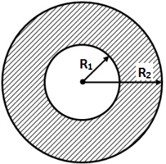

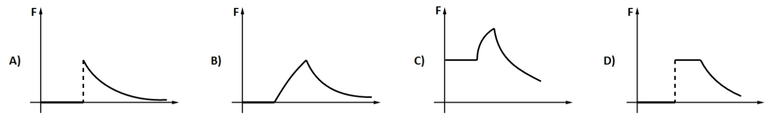

1. Two concentric spherical shells are as shown in the figure. The $v$- $r$ graph will be as

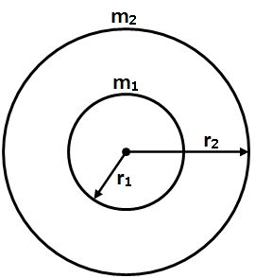

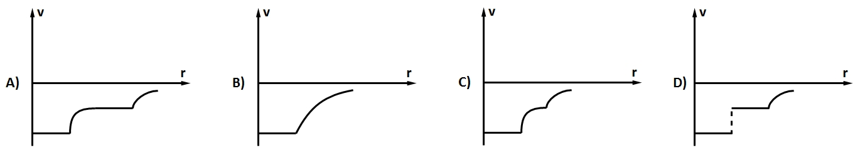

1. If the radius of a solid sphere is decreased to half, keeping density of sphere unchanged, the slope of $E$- $r$ graph inside the sphere will
2. remain unchanged
3. become two times
4. becomes four times
5. remain th
6. A particle is projected from the surface of the earth with velocity equal to its escape velocity, at $45°$ with horizontal. What is the angle of its velocity with horizontal at height $h=R$. (Here horizontal at some point means a line parallel to tangent on earth just below that point).

$30°$

$60°$

$cos^{-1}\left(1/3\right)$

$cos^{-1}\left(1/4\right)$

*Q35. Let $V$ and $E$ be the gravitational potential and gravitational field. Then select the correct alternative(s)

1. The plot of $E$ against $r$ (distance from centre) is discontinuous for a spherical shell
2. The plot of $V$ against $r$ is continuous for a spherical shell
3. The plot of $E$ against $r$ is discontinuous for a solid sphere
4. The plot of $V$ aginst $r$ is continuous for a solid

*Q36. In circular orbit of a satellite

1. orbital speed is $\sqrt{\frac{GM}{r}}$
2. time period $T^{2}∝r^{3}$
3. kinetic energy is $\frac{GMm}{2r}$
4. potential energy is $-\frac{GMm}{2r}$

*Q37. If a body is projected with speed lesser than escape velocity

1. the body can reach a certain height and may fall down following a straight line path
2. the body can reach a certain height and may fall down following an approximately parabolic path
3. the body may orbit the earth in a circular orbit
4. the body may orbit the earth in an elliptic orbit

Passage [Q. Nos. 38-41] Three equal masses each of mass $'m'$ are placed at the three-corners of an equilateral triangle of side $'a^{'}.$

1. If a fourth particle of equal mass is placed at the centre of triangle, then net force acting on it, is equal to
$\frac{Gm^{2}}{a^{2}}$

$\frac{4Gm^{2}}{3a^{2}}$

$\frac{3Gm^{2}}{a^{2}}$

2. Zero
3. In the above problem, if fourth particle is at the mid-point of a side, then net force acting on it, is equal to
$\frac{Gm^{2}}{a^{2}}$

$\frac{4Gm^{2}}{3a^{2}}$

$\frac{3Gm^{2}}{a^{2}}$

4. Zero
5. If the given system of masses placed at three vertices of an equilateral triangle of side $a$ is to be changed to side of $2a$, then work done on the system is
$\frac{3Gm^{2}}{a}$

$\frac{3Gm^{2}}{2a}$

$\frac{4Gm^{2}}{3a}$

$\frac{Gm^{2}}{a}$

6. In the above system, if two particles are kept fixed and third particle is released, then speed of the particle when it reaches to the midpoint of the side connecting other two masses is









Passage [Q. Nos. 42-44] A pair of stars rotates about a common centre of mass. One of the stars has a mass $M$ and the other has mass $m$ such that $M=2m$. The distance between the centres of the stars is $d$ ( $d$ being large compared to the size of either star).

1. The period of rotation of the stars about their common centre of mass (in terms of $d, m, G$) is
$\sqrt{\frac{4π^{2}}{Gm}d^{3}}$

$\sqrt{\frac{8π^{2}}{3Gm}d^{3}}$

$\sqrt{\frac{2π^{2}}{3Gm}d^{3}}$

$\sqrt{\frac{4π^{2}}{3Gm}d^{3}}$

2. The ratio of the angular momentum of the two stars about their common centre of mass $\left(L_{M}/L_{m}\right)$ is
3. 1
4. 2
5. 4
6. 9
7. The ratio of kinetic energies of the two stars $\left(K_{m}/K_{M}\right)$ is
8. 1
9. 2
10. 4
11. 9
12. Two concentric spherical shells are as shown in the figure. Match the following.

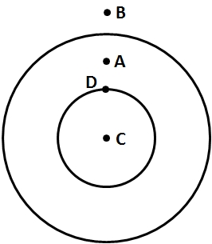

|  |  |
| --- | --- |
| Table -1 | Table-2 |
| 1. Potential at 2. Gravitational field at 3. As one moves from to 4. As one moves from to | 1. Greater than 2. Less than 3. Potential remains constant 4. Gravitational field decreases 5. Data insufficient |

1. In an elliptical orbit of a planet, as the planet moves from apogee (aphelion) position to perigee (perihelion) position, match the following tables.

|  |  |
| --- | --- |
| Table -1 | Table-2 |
| 1. Speed of planet 2. Distance of planet from centre of sun 3. Potential energy 4. Angular momentum about centre of sun | 1. Remains same 2. Decreases 3. Increases 4. Cannot say |

1. If rotational speed of the earth decreases without change in other factors. Match the following.

|  |  |
| --- | --- |
| Table -1 | Table-2 |
| 1. Value of at pole 2. Value of at equator 3. Potential energy 4. Angular momentum about centre of sun | 1. Remains same 2. Decreases 3. Increases 4. Cannot say |

ϯQ48. The diameters of two planets are in the ratio $4:1$ and their mean densities are in the ratio $1:2$. Find the ratio of the acceleration due to gravity on their surfaces.

ϯQ49. The density of the core of a planet is $x$ and that of outer shell is $y$. The radii of the core and that of the planet are $R$ and $2R$. The acceleration due to gravity at the surface of planet is same as at a depth $R$. The ratio of $x$ and $y$ is $n/3$. Find the value of $n$.

ϯQ50. A body is projected vertically upwards from the surface of the earth with a velocity equal to half the escape velocity. If $R$ be the radius of earth, maximum height attained by the body from the surface of the earth is $R/n$. Find value of $n$.

ϯQ51. Two particles of equal mass $m$ go around a circle of radius $R$ under the action of their mutual gravitational attraction. The speed of each particle is $v=\sqrt{\frac{Gm}{nR}} .$ Find the value of $n$.

ϯQ52. An artificial satellite is moving in a circular orbit around the earth (radius $R$) with a speed equal to half the magnitude of the escape velocity form the earth. The height of the satellite above the surface of the earth is $x R.$ Find the value of $x$.